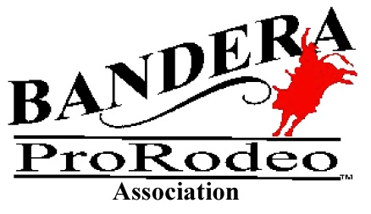

BANDERA PRORODEO ASSOCIATION
PO Box 457 BANDERA, TEXAS 78003
2024 FOOD AND/OR COMMERCIAL BOOTH EXHIBIT APPLICATION
Rodeo dates and hours: May 24, 25 & 26, 2024, admission gates open at 6:30 pm and Rodeo
performances will begin at 8:00 pm each evening. See above rules for time deadlines that apply to
vendor set up and close down.
Please circle the size and rental amount of the type of booth that you are requesting
10 x 10 $150.00 Or 10 x 20 $175.00
Please indicated below what electrical outlets you will need, understanding that you will be charged
$15.00 a day for 110 outlets and $34.00 a day for 30 amp outlets. Special arrangements will have to be
made for 50 amp outlets and the charge will be $37.00 a day.
Attach a complete list of all merchandise and/or food products to be sold
PLEASE NOTE THAT BPRA RESERVES THE RIGHT TO SELL ALL ALCOHOLIC
BEVERAGES EXCLUSIVELY DURING THE RODEO
Applicant requests: (You Must Circle Your Choice if You want an Outlet)
110 outlet at $15.00 a day 30 amp outlet at $34.00 a day 50 amp outlet at $37.00 a day
Applicant: Name:___________________________________________________________
Contact Person:___________________________________
Phone: ___________________ Cell:________________________
Address:_______________________ City ______________________State/zip_______________
Email Address:________________________________________
Trailer length___________, Trailer width __________________, Tongue length_______
A picture of your trailer, showing which side is open to the public, must be attached to this application
This application does not automatically reserve space or guarantee a contract unless payment is
enclosed. If you have any questions please contact: Eric Kellmann at (713) 502-9905; email: j_eric@earthlink.net

By signing this application, Vendor agrees to all Rules and Terms and Conditions.
Signature:____________________________________
Print Name________________________________
Please return this application, with payment, and signed agreement no later than May 1, 2024. Keep
the Terms and Conditions page for your records. Mail application to:
Bandera ProRodeo, P.O. Box 457, Bandera, TX 78003 or email to durocher1961@gmail.com
FOR INTERNAL USE ONLY: DATE PMT RECD:_____________CHECK
#:___________AMT:___________

