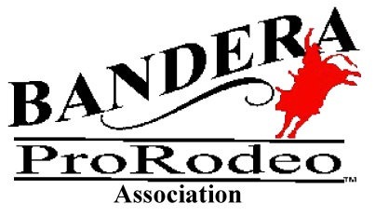
BANDERA PRO RODEO ASSOCIATION
VENDOR TERMS AND CONDITIONS
May 24, 25 & 26, 2024
Please Note: This is an outdoor event!

Application: A complete list of all merchandise and/or food products must be attached to your
application.
Vendor applications will be reviewed for approval. You will be notified within
three (3) days if your application is questioned. Approval of menu or booth content will be at the sole
discretion of the BPRA vendor chairperson. We will be limiting the number of vendors selling similar
items. A Vendor Agreement will need to be signed. (See following page) In the spirit of Memorial Day,
veteran-owned businesses will receive a $20.00 credit toward their vendor fee.
Health Certificate: Food vendors must have current health certificate displayed during business hours.
Vendor check in times: All vendors should be checked in no later than 4:30 pm on Friday. All vendors
must be set up and ready to sell by 6:00 p.m. each night. If a vendor is not set up by 6:00 pm on Friday,
the vendor will forfeit Friday night, but will be allowed to set up for Saturday and Sunday’s
performances. BPRA chairperson will make final decision.
Booth location: The location of each booth will be at the sole discretion of the BPRA vendor chairperson.
Spaces are limited therefore they will be assigned based on date each application and payment are
received (first come, first served basis).
Booths: If selling out of a trailer, photos are required showing which side of trailer is open to the public.
Exhibitors must furnish their own display needs. All merchandise MUST be displayed and stored within
the marked boundaries of the assigned exhibit space.
Rental Refunds: If vendor cancels prior to May 1st , vendor will be due a full refund. If vendor cancels
after May 1st , 2024, but prior to May 15th , 2024, vendor will be refunded 50% of amount paid. If vendor cancels on or after May 16th, 2024, vendor forfeits any refund.
Electrical Hookups: 110 outlets are available at the rate of $15.00 a day. This is the rate charged the
Association by the County. There are 30 amp outlets at the rate of $34.00 a day. Any available 50 amp
outlet will be $37.00 a day. Please designate what, if any, electrical outlets you will need in your
application. All these charges are assessed against Bandera ProRodeo by Bandera County.
Ice: If needed, please call prior to arrival to place your order for ice. You will be charged an additional
amount to reimburse the Association for the ice you need.
Change: Please be prepared and have plenty of change for your business.
Sublet: No vendor is allowed to sublease the space assigned to them.
Admission Gates will be opened at 6:30 pm and locked at 12:00 am each night. All other gates will be
locked at 6:00 p.m. which is why vendors must be set up by that time. An Association representative will
have keys in case a vendor needs to gain access or egress through a gate. All vendor spaces must be
cleaned up and shut down by 11:45 pm each evening. NO EXCEPTIONS
BPRA will not be responsible for vendor’s merchandise or vendor’s property.

